*Binary* classification is classification with two categories. For example, we could label patients as non-diabetic or diabetic.

The class prediction is made by determining the *probability* for each possible class as a value between 0 -impossible - and 1 - certain. The total probability for all classes is 1, as the patient is definitely either diabetic or non-diabetic. So, if the predicted probability of a patient being diabetic is 0.3, then there is a corresponding probability of 0.7 that the patient is non-diabetic.

A threshold value, usually 0.5, is used to determine the predicted class - so if the *positive* class (in this case, diabetic) has a predicted probability greater than the threshold, then a classification of diabetic is predicted.

**Training and evaluating a classification model**

Classification is an example of a *supervised* machine learning technique, which means it relies on data that includes known *feature* values (for example, diagnostic measurements for patients) as well as known *label* values (for example, a classification of non-diabetic or diabetic). A classification algorithm is used to fit a subset of the data to a function that can calculate the probability for each class label from the feature values. The remaining data is used to evaluate the model by comparing the predictions it generates from the features to the known class labels.

**A simple example**

Let's explore a simple example to help explain the key principles. Suppose we have the following patient data, which consists of a single feature (blood-glucose level) and a class label 0 for non-diabetic, 1 for diabetic.

| A simple example | |
| --- | --- |
| **Blood-Glucose** | **Diabetic** |
| 82 | 0 |
| 92 | 0 |
| 112 | 1 |
| 102 | 0 |
| 115 | 1 |
| 107 | 1 |
| 87 | 0 |
| 120 | 1 |
| 83 | 0 |
| 119 | 1 |
| 104 | 1 |
| 105 | 0 |
| 86 | 0 |
| 109 | 1 |

We'll use the first eight observations to train a classification model, and we'll start by plotting the blood-glucose feature (which we'll call ***x***) and the predicted diabetic label (which we'll call ***y***).

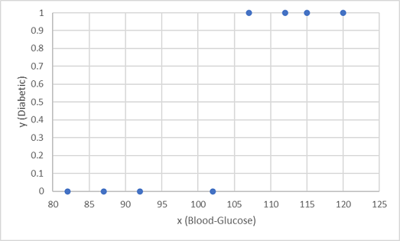

What we need is a function that calculates a probability value for ***y*** based on ***x*** (in other words, we need the function ***f(x) = y***). You can see from the chart that patients with a low blood-glucose level are all non-diabetic, while patients with a higher blood-glucose level are diabetic. It seems like the higher the blood-glucose level, the more probable it is that a patient is diabetic, with the inflexion point being somewhere between 100 and 110. We need to fit a function that calculates a value between 0 and 1 for ***y*** to these values.

One such function is a logistic function, which forms a sigmoidal (S-shaped) curve, like this:

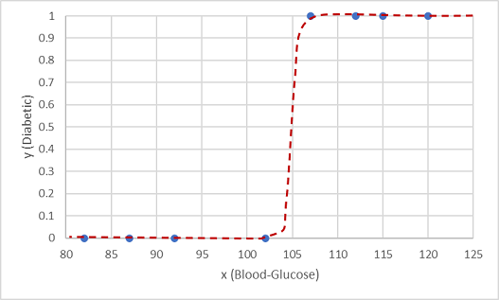

Now we can use the function to calculate a probability value that ***y*** is positive, meaning the patient is diabetic, from any value of ***x*** by finding the point on the function line for ***x***. We can set a threshold value of 0.5 as the cut-off point for the class label prediction.

Let's test it with the data values we held-back:

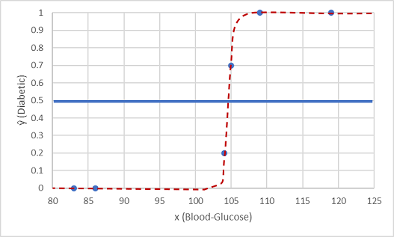

Points plotted below the threshold line will yield a predicted class of 0 - non-diabetic - and points above the line will be predicted as 1 - diabetic.

Now we can compare the label predictions based on the logistic function encapsulated in the model (which we'll call ***ŷ***, or "y-hat") to the actual class labels (***y***).

| Table 2 | | |
| --- | --- | --- |
| **x** | **y** | **ŷ** | |
| 83 | 0 | 0 | |
| 119 | 1 | 1 | |
| 104 | 1 | 0 | |
| 105 | 0 | 1 | |
| 86 | 0 | 0 | |
| 109 | 1 | 1 | |
|  |  |  | |